**NAS Server Configuration using NFS Protocol**

**On Server Side**

* **Assign a GPT style Partition table to the HDD & start creating partitions into it.**

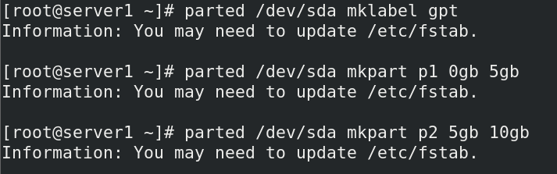

* **Verify if the disk partitions are created perfectly.**

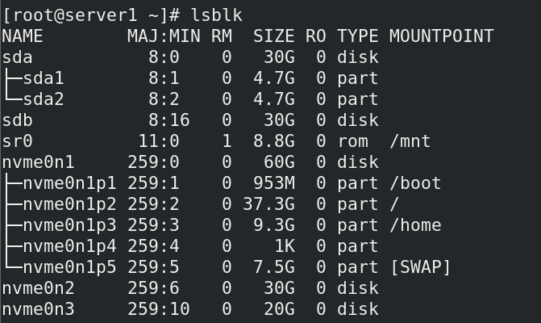

* **Format the Appropriate Disk Partitions for data storage purpose.**

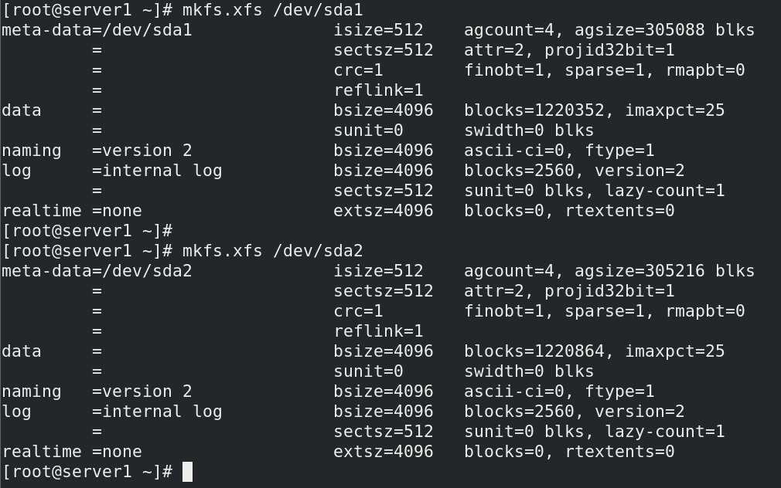

* **Create 2 new folders that will act as mount point for our disk partitions. After that, mount these partitions onto respective mount points. Also Verify for the same.**

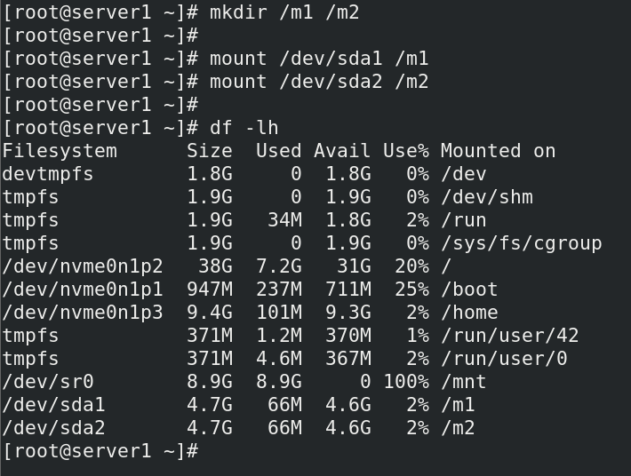

* **Now check if the following packages are available for configuration of NFS server**

**(rpcbind, nfs-utils). If not present download the following packages.**

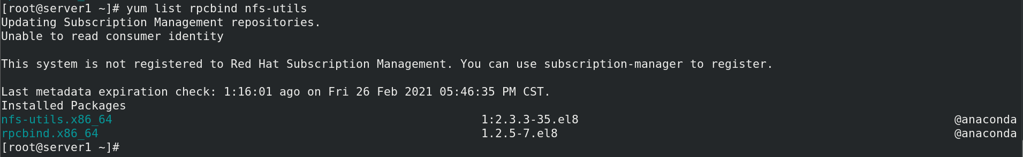

* **Now enable the following services to bring NFS Server into action**



* **Now disable the Firewall since NFS server uses random port numbers & also check the status of the firewall.**

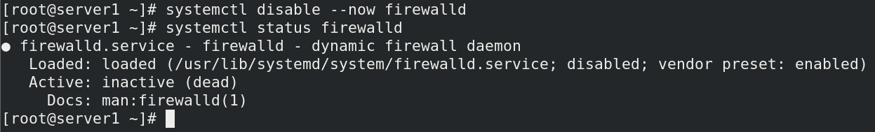

* **Edit the /etc/exports file & write the folder (mount point) that you want to share in the network along with client IP address whom you want to export this folder.**

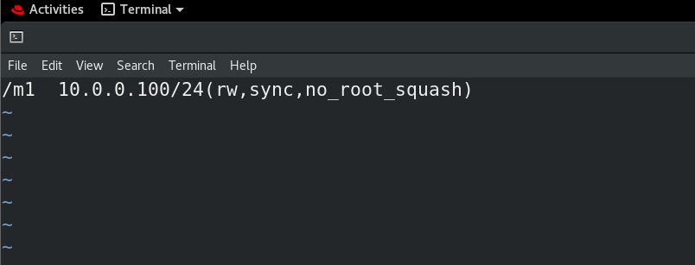

* **This is one of the important steps, now execute a command to export the local mounted directory to NFS clients in the network.**

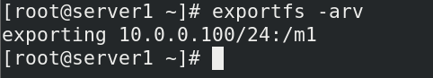

**On Client Side**

* **Now execute a command, that will show all the exported folders by the NFS server**

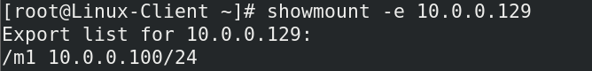

* **Perform NFS mounting in order to mount exported directory onto local directory.**



* **Add some data into this local Directory (mount point), also verify it for the same.**

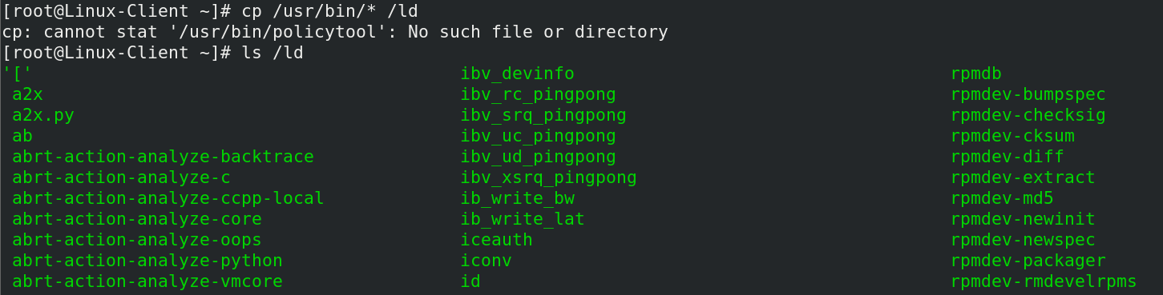

**On Server Side**

* **Verify the same data is replicated into /m1 folder that was copied in /ld folder.**

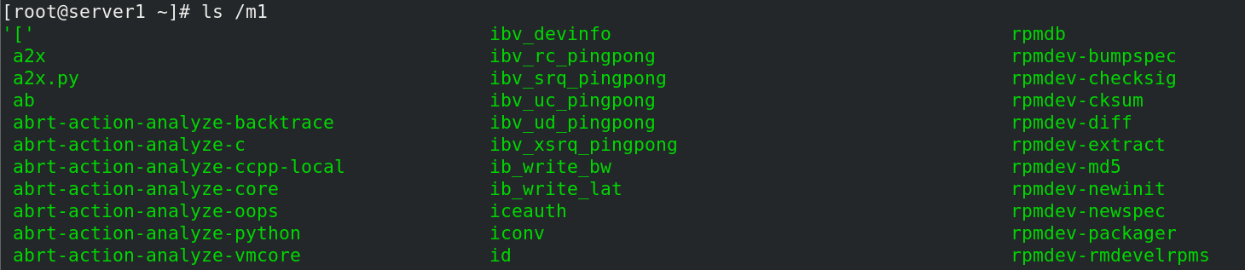

* **Verify & print the storage used by m1.**

